R- Assignment 3

Text Document-

1. What are some of the differences between an array and a data frame?

Array entries are only one data type where in a data frame each column can have a different data type

Each row in a data frame is an observation of one entry

1. Below is a view of the top portion of alc_abuse.txt. What delimiter is used to separate values in this file?

**| | | |**

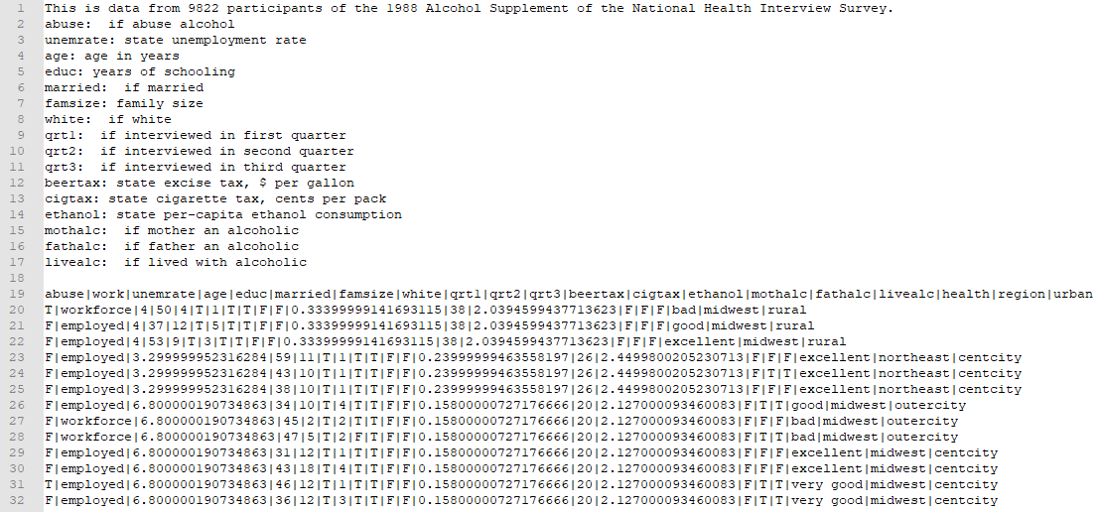

R Script-

1. Import the data beginning in line 19 of alc_abuse.txt as a data frame.
   1. How many variables are recorded in the data in this file?

20

* 1. How many rows of data are there?

9822

* 1. What percent of the participants in this data frame are married?

81.64%

1. Use the map() function to find the mean of every column in mtcars.

> mtcars %>% map_dbl(mean)

mpg cyl disp hp drat wt qsec vs am gear carb

20.090625 6.187500 230.721875 146.687500 3.596563 3.217250 17.848750 0.437500 0.406250 3.687500 2.812500

Complete the following exercises based on the flights tibble from the nycflights13 package:

1. Sort flights by carrier and within each carrier, sort flights by distance.
2. Find all the flights that arrived at least one hour late but did not depart late.
3. Use the between( ) operator within a filter( ) function to find all the flights that were scheduled to depart between 12:00am and 4:00am. *(Note: in the data, 12:00am is represented as time 000)*
4. Of the planes (talinum, in the dataset) that flew at least 20 flights, which one had the highest average arrival delay time?
5. Add a row of values to flights using the add_row() function. Your new row should contain data for each variable (data you make up) and should not be empty.